TUPC Learning Commons Development
Installation of Requirements

System Requirements:
- Python 3.9
- Flask
- MySQL Connector
- QR Code Library
- Visual Studio Code
- XAMPP
- Python VS Code Extension
- TUPC Learning Commons System Files
- VS Code Virtual Environment
- Setting up the Learning Commons Database
- Opening and Testing TUPC-LC System Files

Part 1: Installing Python 3.9
- Go to this website and download the .exe file
https://www.python.org/ftp/python/3.9.0/python-3.9.0-amd64.exe

- Run the .exe file
- Check/Tick the “Add Python to PATH” [IMPORTANT]
- Click on “Install Now”

Note: Make sure that there are no other Python versions installed

Part 2: Installing Flask
- Open Command Prompt/Terminal as administrator
- Confirm the Python and pip install

python –-version
python -m pip --version

- Install Flask

python -m install flask

- Verify Flask installation

python -m flask –version

Part 3: Installing MySQL Connector (Python)
- Open Command Prompt/Terminal as administrator
- Install MySQL Connector

python -m pip install mysql-connector-python

Part 4: Install QR Code Library (Python)
- Open Command Prompt/Terminal as administrator
- Install QR Code Library

pip install qrcode[pil]

Part 5: Installing Visual Studio Code
Note: You may skip this step if you already have VS Code installed

- Open this website and download the .exe file
https://code.visualstudio.com/sha/download?build=stable&os=win32-x64-user

- Click on “Next” until you’ve reached the “Select Additional Tasks” section of the install
- Make sure that you have “Register Code as an editor for supported file types” and “Add to PATH (requires shell restart)”.

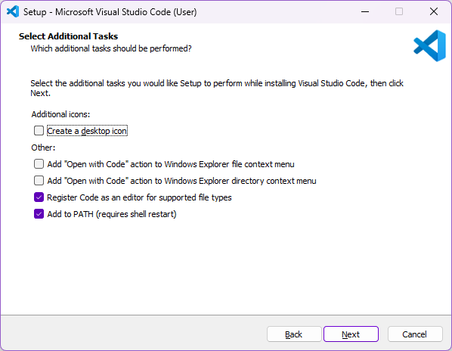

- Click on “Install” and wait for the installation to finish

Part 6: Installing XAMPP
- Open this website and download the latest version
https://www.apachefriends.org/download.html

- Run the installer
- Make sure have the following components selected
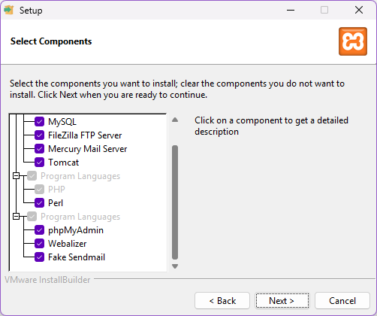

- Keep the installation path as is (C:\xampp)
- Click on “Next” and “Install”
- Wait for the installation to finish

Part 7: Installing Python VS Code Extension
- Open Visual Studio Code
- Go to the “Extensions” tab
- Search for “Python”
- Select “Python” by Microsoft
- Click on “Install”

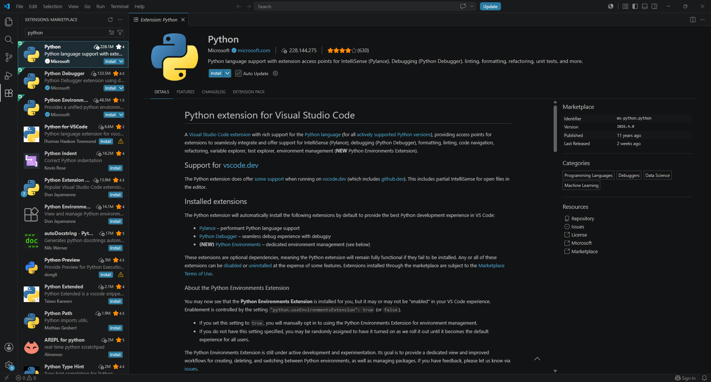

Part 8: Opening the TUPC Learning Commons System Files
- Open this Google Drive link using your GSFE account to access the System Files folder
https://drive.google.com/drive/folders/17elSbiWlp6OGEYbU_985ZLCLyUF1NKOy?usp=drive_link

- Download the latest system update and extract the .zip file once downloaded
- Open Visual Studio Code and open the TUPC Learning Commons folder that you’ve just downloaded

Note: To open both admin and kiosk systems at the same time, make sure to go to File -> New Window -> *and select the folder you want to open

Part 9: Creating a Virtual Environment
- Open the TUPC Learning Commons folder in VS Code
- Click the search bar located in the top part of the screen
- Click on Ctrl + P
- Click on “Create Environment”

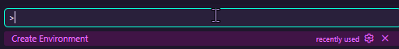

- Select “venv” [IMPORTANT]
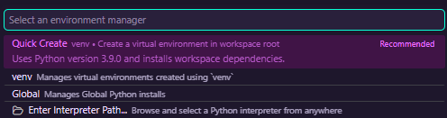

- Select “Python 3.9 (64-bit)” [IMPORTANT]
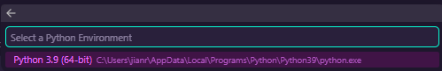

- Keep the environment name as is and press Enter
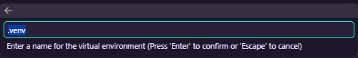

Important Note: Make sure to do this on all folders (tupclc_adminsystem, tupclc_kiosksystem, and tupclc_trackingsystem) of the TUPC Learning Commons

Part 10: Setting up the Learning Commons Database
- Open the TUPC Learning Commons System Files Google Drive Folder
- Download “learning_commons_db.sql” file located on the main folder. You may also click the link below for the direct download.
https://drive.google.com/file/d/10SsV2BEuWhVfRJG-pLaf70deW5M5GTZH/view?usp=sharing

- Open XAMPP and select “Admin” under MySQL.
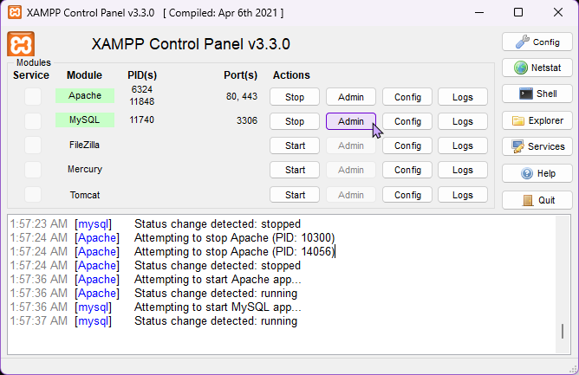

- On the left sidebar, click on “New”
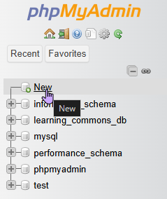

- Look for the “Import” tab and click it.
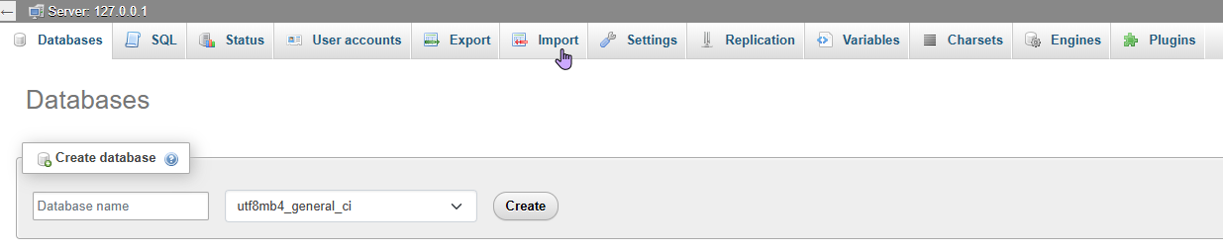

- Click on “Choose File” and look for “learning_commons_db.sql” file.
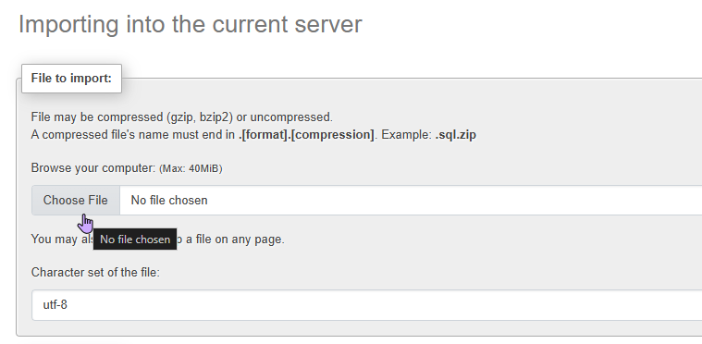
- Scroll down and click on “Import”
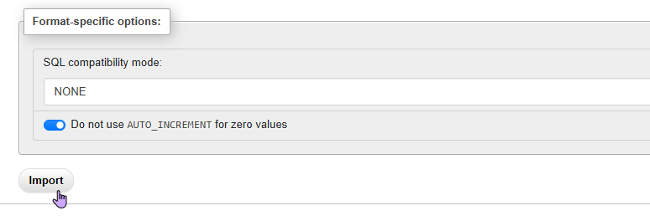

- Check if the database has been imported. The database should look like this:
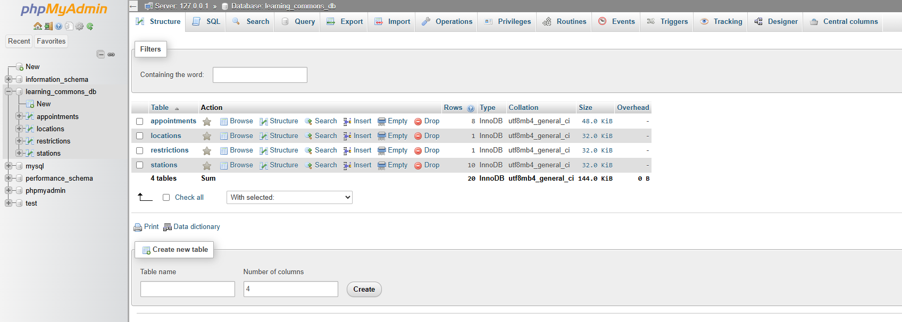

Part 11: Opening and Testing TUPC-LC System Files
- Open XAMPP Control Panel
- Start “Apache” and “MySQL”
- Open the TUPC Learning Commons folder
- Look for app.py and click on the “Run Python File” button (look for the “play” button) located at the tabs section to open the VS Code’s built-in terminal
- On the terminal below, type the following command

flask --app app.py --debug run

- Press alt + click on http://120.0.0.1:5000 to open the program and test it
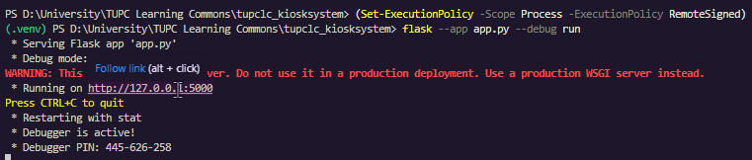

Admin System Login Password
Username: admin
Password: 1234

Notes:
- You may skip Steps 1 to 10 if you are opening the system files for the second time onwards since it is only a one-time procedure.
- To open a new system file (from kiosk to admin and vice versa), press Ctrl + C to close the debugger and run the flask command on the other folder. The debugger can only open once app.py file at a time.
- Some system features require the usage of a QR code scanner hardware.

